SIMATS ENGINEERING
ASSESSMENT TOOL 1

COURSE NAME: Artificial Intelligence COURSE CODE: CSA17

COURSE OUTCOME COVERED

CO2: Experiment search and game-solving techniques such as Greedy Search, A*, CSP, Minimax, and Alpha-Beta pruning with heuristic functions for solving complex AI problems efficiently. (BL3)

Assessment Tool Weightage: 40%

Duration: 1 Hour
QUESTIONS: 3 Total Marks:30

Annexure A

Application Based Questions

Code of Conduct:

I ____________________ (Name / Reg No) certify that this submission is my original work and that I have adhered to the guidelines specified for this assessment.
I understand that any violation of academic integrity rules will result in disciplinary action.

Signature of the student:

Annexure A

Application Based Questions

1. Intelligent Route Planning using A* and Greedy Search.
A smart delivery system is designed to transport medical supplies between cities. The system uses informed search strategies to determine optimal routes.
The road network is given below:
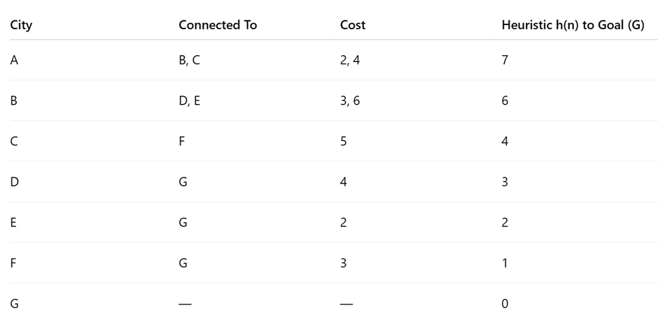
Tasks:
- Construct the search tree from A to G.
- Apply Greedy Best-First Search and show node expansion order.
- Apply A* algorithm using 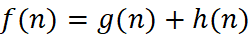.
- Justify which algorithm is better for real-time emergency delivery systems.
2. Constraint Satisfaction Problem – University Timetable Scheduling
A university must schedule final exams for 5 subjects: AI, ML, DBMS, OS, CN across 3 days (Day 1, Day 2, Day 3) with the conditions, AI and ML cannot be scheduled on the same day, DBMS must be scheduled before OS, CN cannot be on Day 1, At most 2 exams per day, A student is enrolled in AI, DBMS, and CN → these cannot overlap
Tasks:
- Formulate this problem as a Constraint Satisfaction Problem (CSP) by defining, Variables, Domains and Constraints
- Draw the constraint graph.
- Solve using Backtracking Search.
- Apply Forward Checking or Arc Consistency and explain how it reduces the search space.
- Provide one valid timetable solution.

3. Game Playing – Minimax and Alpha-Beta Pruning
An AI agent is designed to play a turn-based strategy game. The game tree is given below:
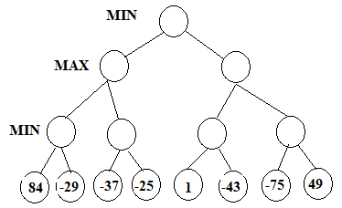
Tasks:
- Apply the Minimax algorithm and compute values for all internal nodes.
- Identify the optimal move for MAX.
- Apply Alpha-Beta Pruning to Show α and β values at each step and Clearly indicate which nodes are pruned
- Compare nodes evaluated in Minimax vs Alpha-Beta
- Explain the importance of evaluation functions in complex games like chess.

2- Constraint Satisfaction Problem (CSP)

i. Formulate the CSP

Variables
AI
ML
DBMS
OS
CN

Domains
Day1
Day2
Day3

Constraints
- AI ≠ ML
- DBMS before OS
- CN ≠ Day1
- Maximum 2 exams each day
- AI, DBMS and CN cannot overlap

ii. Draw the Constraint Graph
AI ------- ML
|
|
DBMS ------ OS
|
|
CN
Explanation
- AI connected to ML
- DBMS connected to OS
- AI connected to DBMS
- DBMS connected to CN
Each edge represents a scheduling constraint.

iii. Solve Using Backtracking Search
Step 1
Assign
AI = Day1
Step 2
ML cannot be Day1
ML = Day2
Step 3
DBMS
DBMS = Day1
Step 4
OS must come after DBMS
OS = Day2
Step 5
CN cannot be Day1
CN = Day3
Final Schedule
Subject | Day
AI | Day1
DBMS | Day1
ML | Day2
OS | Day2
CN | Day3
This satisfies all given constraints.

iv. Forward Checking
Forward Checking removes values from the domains that would violate constraints after each assignment.
Example
Assign
AI = Day1
Then remove
Day1 from ML
Assign
DBMS = Day1
Then
OS cannot be before Day1

Advantages
- Reduces search space.
- Detects conflicts early.
- Improves efficiency.
- Decreases unnecessary backtracking.

v. One Valid Timetable Solution
Day | Subjects
Day1 | AI, DBMS
Day2 | ML, OS
Day3 | CN
This timetable satisfies:
- AI and ML are on different days.
- DBMS is before OS.
- CN is not on Day1.
- No day has more than two exams.
- AI, DBMS, and CN do not overlap.

RUBRICS FOR CALCULATION

Criteria | Weightage | Level 4 – Exemplary | Level 3 – Proficient | Level 2 – Developing | Level 1 – Beginning
Understanding of Problem Context | 20 | Clearly understands the problem and accurately identifies all requirements | Good understanding with minor gaps | Basic understanding; some requirements unclear | Poor understanding or misinterpretation of the problem
Application of Concepts | 30 | Accurately applies appropriate concepts to solve complex problems | Applies relevant concepts correctly with minor errors | Applies basic concepts with limited accuracy | Fails to apply appropriate concepts
Problem-Solving Approach | 20 | Logical, well-structured, and efficient approach | Mostly logical approach with minor gaps | Basic approach with some inconsistencies | Illogical or unclear approach
Accuracy of Solution | 20 | Completely correct solution with proper justification | Mostly correct with minor errors | Partially correct solution | Incorrect or incomplete solution
Clarity | 10 | Clear, well-organized, and properly explained solution | Understandable with minor clarity issues | Limited clarity and explanation | Poorly presented and difficult to understand

Answers

1- Intelligent Route Planning using A and Greedy Search*

i. Construct the Search Tree from A to G
The search tree begins at the start node A and expands through all possible neighboring cities until the destination G is reached.
Example Search Tree:
A
/ | \
B C D
/ | | |
E F G H
/ |
G Goal
- Root Node = A
- Goal Node = G
- Every branch represents a possible road between cities.
- The search tree helps the algorithm determine which route to expand.

ii. Apply Greedy Best-First Search

Definition
Greedy Best-First Search chooses the node that appears closest to the goal using only the heuristic value h(n).
Formula:
f(n)=h(n)f(n)=h(n)f(n)=h(n)
Where
- h(n) = Estimated distance from node to goal

Working
- Start from node A.
- Check all neighboring nodes.
- Choose the node with the smallest heuristic value.
- Continue until G is reached.

Example Node Expansion
Suppose
Node | Heuristic h(n)
A | 12
B | 8
C | 5
D | 9
G | 0
Expansion Order:
A → C → G

Advantages
- Fast
- Requires less memory
- Good for emergency applications

Disadvantages
- Does not always give the shortest path.
- Can become trapped in a local optimum.

iii. Apply A Algorithm*

Definition
A* Search combines both
- Actual path cost
- Estimated cost
Formula
f(n)=g(n)+h(n)f(n)=g(n)+h(n)f(n)=g(n)+h(n)
Where
- g(n)=Actual distance travelled
- h(n)=Estimated distance remaining
Example
Node | g(n) | h(n) | f(n)
A | 0 | 12 | 12
B | 2 | 8 | 10
C | 4 | 5 | 9
G | 7 | 0 | 7
Expansion
A → B → C → G

Advantages
- Always finds the optimal path.
- Complete algorithm.
- Used in navigation systems.

Disadvantages
- Requires more memory.
- Slightly slower than Greedy Search.

iv. Which Algorithm is Better? Justify

Greedy Search
Advantages
- Faster
- Less computation
- Suitable for urgent situations
Disadvantages
- May not find the shortest route.

A*
Advantages
- Produces the shortest path.
- Highly accurate.
- Reliable.

Conclusion
For real-time emergency delivery systems, A* is generally better because it considers both the distance already traveled and the estimated distance remaining, resulting in the most efficient and reliable route. If immediate response is more important than perfect optimality, Greedy Search can be preferred because of its speed

3-Game Playing – Minimax and Alpha-Beta Pruning

i. Apply Minimax Algorithm

Definition
Minimax is used in two-player games.
- MAX tries to maximize the score.
- MIN tries to minimize the score.
Example
MAX
/ \
MIN MIN
/ \ / \
3 5 2 9
MIN values
Left = 3
Right = 2
MAX chooses
Max(3,2)=3
Final Value
3

ii. Identify the Optimal Move
The optimal move for MAX is the branch with the highest Minimax value.
Example
Choose Left Branch
because
3 > 2

iii. Apply Alpha-Beta Pruning

Alpha
Best value for MAX

Beta
Best value for MIN
Example
MAX

α = -∞

β = +∞
After evaluating
3
Alpha becomes
α=3
If another branch cannot produce a value greater than 3, it is pruned.
Example
MAX
/ \
MIN MIN
/ \ / \
3 5 1 (Pruned)
The last node is not evaluated because it cannot improve the result.

iv. Compare Minimax and Alpha-Beta
Feature | Minimax | Alpha-Beta
Nodes Evaluated | All Nodes | Fewer Nodes
Speed | Slower | Faster
Memory | More | Less
Optimal Result | Yes | Yes
Efficiency | Low | High

Conclusion
Alpha-Beta Pruning is more efficient because it skips branches that cannot affect the final decision while still producing the same optimal result.

v. Importance of Evaluation Functions in Chess
Evaluation functions estimate the quality of a game position when the search cannot continue to the end.

Importance
- Helps AI choose the strongest move.
- Reduces computation time.
- Evaluates board positions quickly.
- Guides Minimax and Alpha-Beta search.
- Enables decision-making in large game trees.

Factors Used
- Material advantage
- King safety
- Piece mobility
- Control of the center
- Pawn structure
- Checkmate opportunities

Conclusion
Without an evaluation function, AI would need to examine every possible move, which is impossible in complex games like chess. Evaluation functions allow the AI to make intelligent decisions efficiently.
.

